ENG200010 Engineering Technology Design Project
Assignment 4
Dang Khoa Le
Student ID: 103844421
Major: Bachelor of Software Engineering

Abstract— This document presenting the demonstration of the Assignment 4, Create a VI for user interface of a washing machine.

I. System layers:
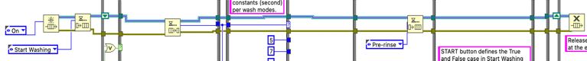
The VI design consist of a Queue Operation - system (using Obtain Queue, Enqueue Element, Dequeue Element, Flush Queue and Release Queue) that align each washing stages and modes on parallel and/or consecutively connected to each other and other components of the system (Buttons, Enum, functions etc) with a reasonable logic.

1. Set Up:
The majority of the system’s components are allocated inside the While loop, which can be aborted by using the On/Off button, linked directly to the loop condition.

2. System Analysis:
Using Obtain Queue and Enqueue Element function to initialise the default (initial) stage of the machine to be Off, which will move to the first stage On (using Enqueue Element) once the loop has been turned on. They will queue out and connect to the Shift register at the edge of the While loop to store their data.

The On/Off button connects to the loop condition and the False case of the (status) Case structure, the STOP button also linked to this Case structure (Boolean T/F):
+ If the On/Off or STOP button is not pressed, the Case is False, the stage will remain at the original On value (Dequeue Element to the current stage), moving upwards to the (mode) Case structure.
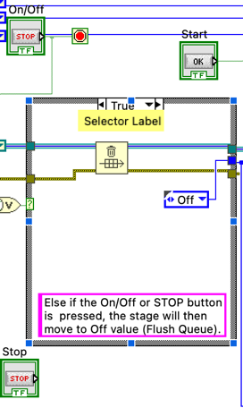
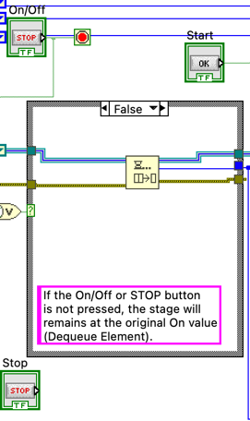
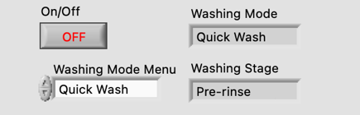
+ Else if the On/Off or STOP button is pressed, the Case is True, the stage will then move to Off value, by Flush Queue to terminate the current On case and link directly the Off stage Enum to the (mode) Case structure.

The Start button is connected to the Start Washing stage of the (stage) Case structure (Boolean T/F):
+ If the Start button is not pressed, the Case is False, the stage will remain at the Start Washing stage, by using Enqueue Element with Start Washing Enum.
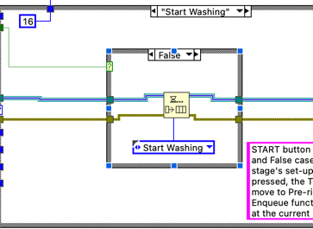
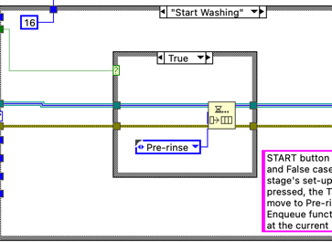
+ Else if the Start button is pressed, the Case is True, the stage will move to the Pre-rinse stage, by using Enqueue Element with Pre-rinse Enum.

The On and Off washing stages will include the Enqueue Element linked with their next stage, meanwhile, the Pre-rinse, Main Wash, Final Spin and Done Washing remained will have the Wait (ms) function additionally.

Eventually, there will be the Release Queue function outside of the loop, queue in from the other end Shift register and release the current loop, revert back to the beginning of the While loop.

II. Mode And Stage - Components:
There are an Enum (set to be Auto-def) to store the washing stages data, including Off, On, Start Washing, Pre-rinse, Main Washing, Final Spin and Done Washing, and a Menu Enum to store 3 washing modes data, including Colorful Mode, Intensive Mode and Quick Wash, which functioning as a string control menu that can be selected from the Front Panel.

All washing modes and stages are stored in the Case structure with one case per each mode and stage.
Each washing modes from the Case structure storing the same set up of stages from the Case structure, apart from the different in time processed and displayed for each stage of different modes.

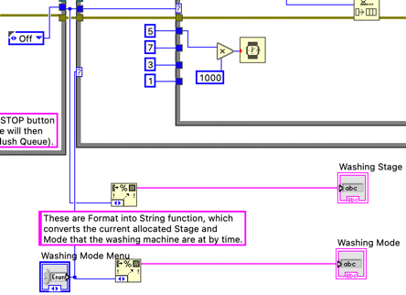
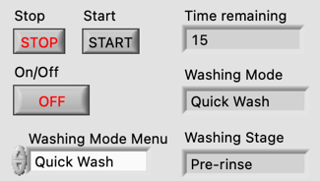
III. Timers:
1. The Loop:
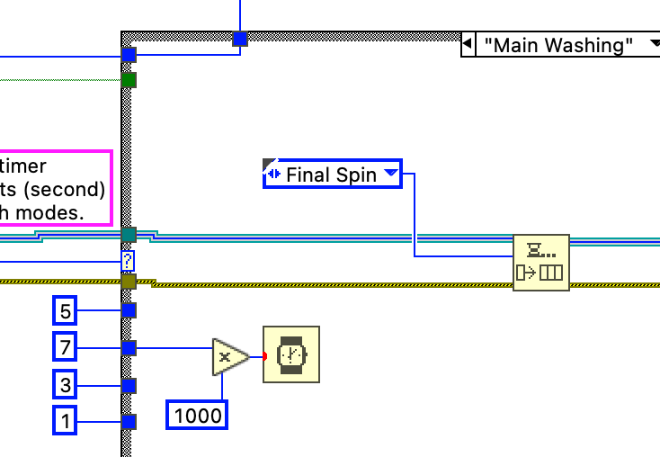
The Wait (ms) function is stored within the Pre-rinse, Main Wash, Final Spin and Done Washing stages to convert the numerical constant (multiplied by 1000) and executed to the required processing time, in order to wait until moving to the next stages.

2. The Display:
Time remaining indicator displaying the integer value of the countdown - time that each mode (consist of Pre-rinse, Main Washing and Final Spin stages) remained before switching back to Start Washing (idle) mode.

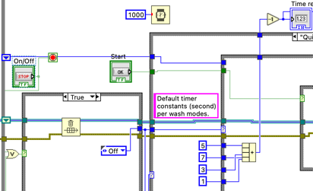
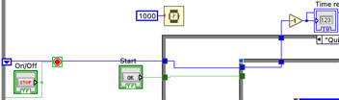
In foremost, there is a Shift register to store the previous data of the time, which will move continuously into all (mode) Case structures and (stage) Case structures, out to the loop, whereas there are a 1000 (ms) Wait time function with attribute to the ‘-1’ (Decrement) function, which allows the loop to re-decrease the integer data from the Shift register by 1 unit each 1 second. At the Start Washing stage, which was implemented to be the Idle stage, there will be a Compound arithmetic function to accumulate the total waiting time that each mode has per washing stages and connected to the Shift register wiring. By using this logic, once when the Start button is ignited, the (stage) Case structure will move to Pre-rinse, making the Shift register wiring being connected from 2 sides of the loop and enable the time value to be decreased by 1 each 1 second. In addition, also notice that On and Off stage will have the numerical constant 0 connect to the Shift register wiring, which mean the time will be reset at these two stages.

IV. Indicator Displays:
The Washing Mode Menu (Enum) and the element output from Dequeue function (storing stages data) will connect to a Format Into String function, in order to convert data into a string and display the current washing mode or stage to the String indicator named “Washing Stage” and “Washing Mode” at the Front Panel.

There is a “Time remaining” numeric indicator reading the total time to wait for each washing modes and show data at the Front Panel.

